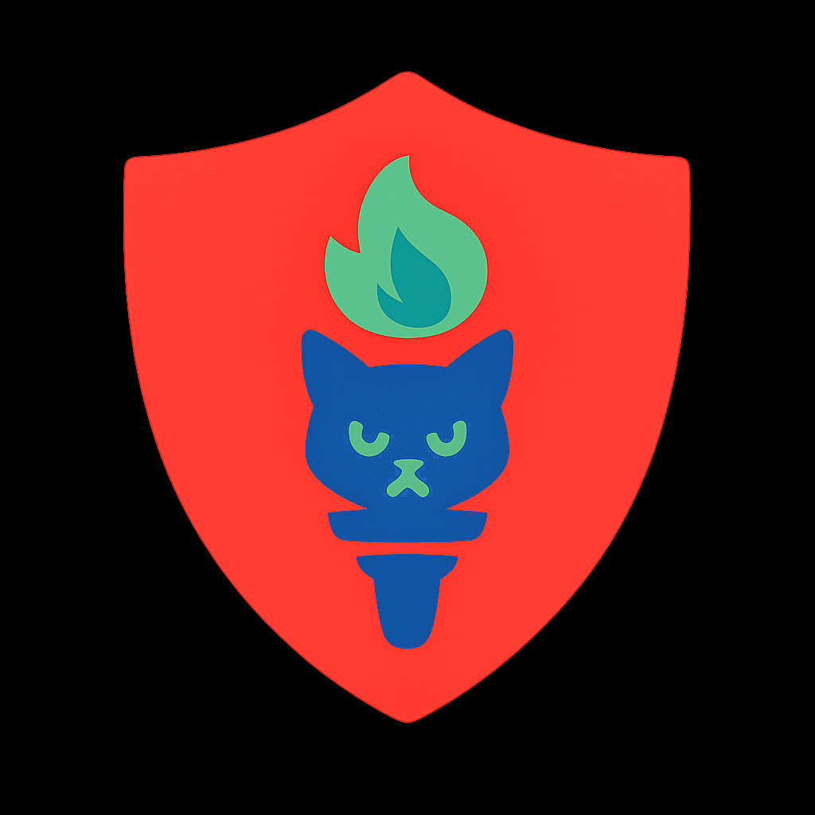 Capstone & Internship Opportunity: GroupBuild

"We Are Legion" — but we are not Anonymous. We are building a social advocacy platform where users remain anonymous, yet still engage in accountable discussions, where:
- Users aren't tracked, profiled and targeted by commercial or political manipulation
- Meritocratic voting is real-time while voters edit voting options
- Ethical-AIs moderate user-behavior (aka “BeAxa”, see warrior-kitten logo)
Have you noticed that — globally — Democracies are in retreat? Have you wished you could do more to help the disenfranchised? Well, this may be your chance to empower "We The People.”
We are not a typical virtual placement. Our team is spread across countries, servers are in foreign safe havens, there is no hierarchy, we all work for free and we pay contractors who can not afford to do the same out of our own pockets. We care enough to be part of the solution. If you have read this far, you probably care as well.

1. [DEV PROJECTS IN FOCUS]
- Advocacy Group creation and promotion, with trust-calibrated roles
- Ethical-AI inline content tagging and Group-chat moderation, with human oversight
- Map-based listings and organization tools for civic actions, e.g. protest rallies, boycotts, town-halls
- Real-time voting on editable decision options (aka “Collaborative Democracy”)

2. [TECHNOLOGIES INVOLVED]
- Frontend: React + TailwindCSS
- Backend: Node.js / Express
- AI Modules: Python (misinfo detection, ethical tagging)
- Infra: WebSockets, PostgreSQL
- Optional: Mapbox API, OAuth, CAPTCHA, Tor-style routing, static site optimization

3. [LEARNING OUTCOMES]
- Git-based open-source workflow experience
- Principles of secure civic tech architectures
- Real-world application of AI-moderated ethical user behavior
- Peer-led development alongside non-hierarchical mentorship
- Public impact: your code helps Democracy self-organize, safely and effectively

4. [THIS PROJECT IS NOT FOR YOU IF YOU:]
- Dislike iterative road maps, or collaborative instructions
- Fear ideological ambiguity, or a future where all ethical beings count
- Believe Democracy is a solved problem, or an obsolete concept
- Build for applause instead of greater purpose
- Are not motivated to “fix the world”, because other people don't matter

5. [MENTORSHIP & SUPPORT]
We’ll work with you and your school to align the dev-project(s) you take ownership of, with your internship or Capstone requirements. Mentorship will come directly from our CEO, Rick Ballard, an angel investor and serial co-founder of $billion tech-unicorns — and now GroupBuild — plus a friendly circle of open-source contributors and technologists who have backgrounds in user/device security, AI-ethics, and social/civic infrastructures. You will almost certainly find your experience personally-transformational, maybe awakening, but we will not provide you with an obsolete, stereotypical “boss”. We meritocratic-vote on strategies, and we answer to our consciences before all else, because together “We The People, Are Legion”, alongside, not above.

6. [TIMELINE / APPLY]
Flexible start dates. Most students engage for 8–12 weeks, with expenses reimbursed, but short intensives or extended volunteer roles are also welcome. Students, Professors, Coordinators — please email Rick Ballard (rick@groupbuild.org) to receive our project brief deck, GitHub access, and a walk-through of potential projects currently in scope. This is not the work of spectators — this is design for the defiant! Welcome to GroupBuild.
Regards, Rick Ballard | +1.416.414.8100 | rick@GroupBuild.org | Bio and Publications

